**Record of Ex. No: 2 – Conics and Special Curves**

**Date of experiment:** 22.04.2021 **Date of submission: .**04.2021

**Name:** Kunal Keshan S **Department:** ECE – A **Roll No:** RA2011004010051

**Aim:**

To draw ***special curves*** of specified dimensions derived from conic sections using AutoCAD.

**Software used:** AutoCAD.

**Procedure:**

|  |  |
| --- | --- |
| Commands Used | Purpose of Command |
| LINE | Used to draw lines of required length. |
| SPLINE | Used to draw smooth curves that pass through a set of predefined points. |
| CIRCLE | Used to draw circle of required radius or diameter. |
| MIRROR | Used to mirror an object or set of objects with respect to a selected plane. |
| DIVIDE | Used to divide an object into equal number of parts by placing points in-between. |
| DDPTYPE | Used to change the style of the marked points. |
| POINT | Used to mark a point anywhere on the sheet. |
| EXPLODE | Used to break an object into its component objects. |
| ARRPOLAR | The **polar array** will consider the same distance for all the copied objects by default. The greater the gap between the center of axis and object, the objects will be copied circularly at the same distance from the axis. |
| OFFSET | The offset command is used to create parallel lines, concentric circles, and parallel curves. |
| TEXT | Used to add text in the sheet. |
| TRIM | Used to remove objects. |
| POLYGON | Used to draw polygons with required/specified number of sides. |
| RAY | Creates a linear object that starts at a point and continues to infinity. |

**Question 1:** Draw a parabola of base 100 mm and height/ length (along the axis) 80 mm, by

1. 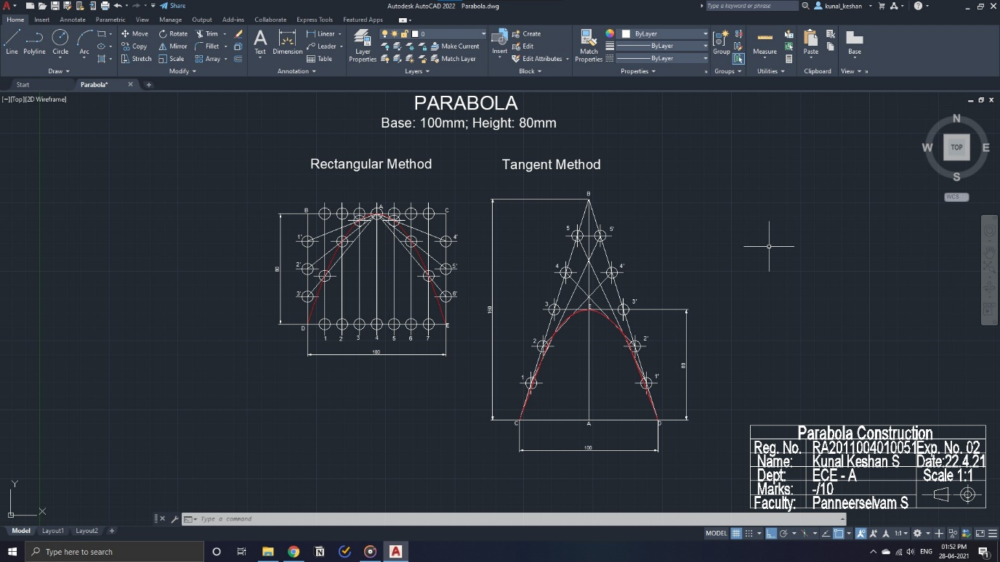Rectangular method, **ii)** Tangent method.

**Question 2:** Draw an ellipse of major diameter/ axis 150 mm and minor diameter/ axis 70 mm by

1. 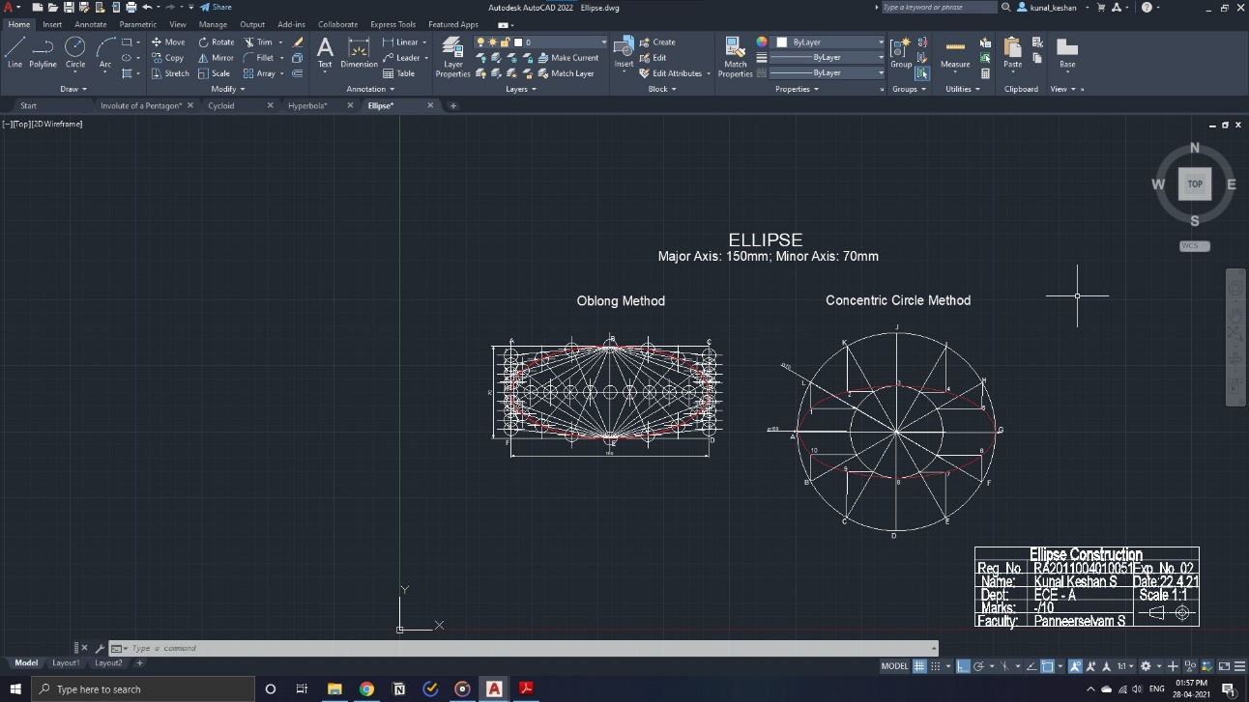Oblong method, **ii)** Concentric Circle method.

**Questions 3:** Draw a hyperbola by eccentricity method with eccentricity, e= 3/2 whose distance of focus is at 50 mm from its directrix.

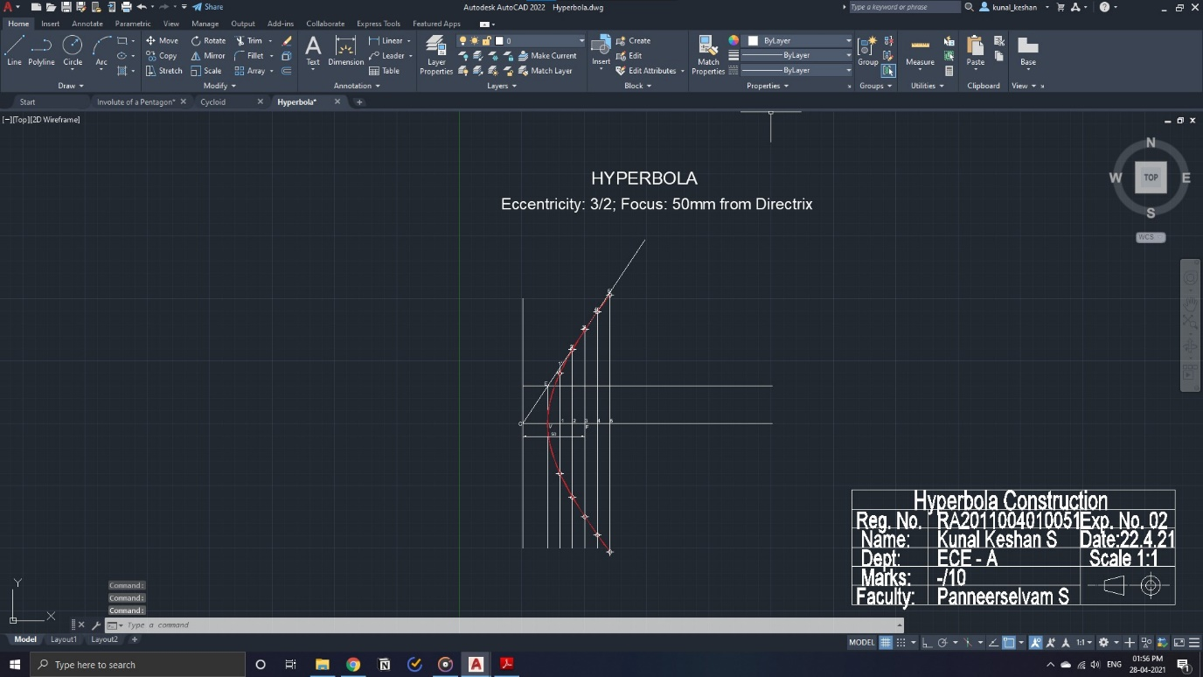

**Questions 4:** Construct a cycloid with rolling circle diameter 60 mm that rolls for one complete revolution, with trace point A, initially at the bottom. **(Epi-cycloid, and hypo-cycloid, demonstration**

**only).**

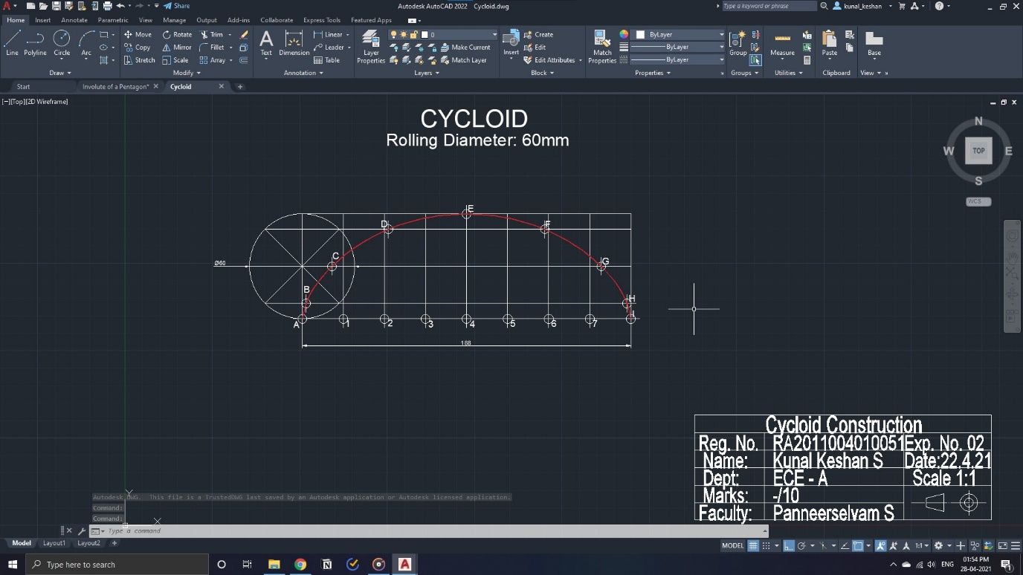

**Questions 5:** Draw the Involute of a regular pentagon (or any polygon) of side 30 mm, wound/ unwound for one complete turn. **(Involute of a circle demonstration only).**

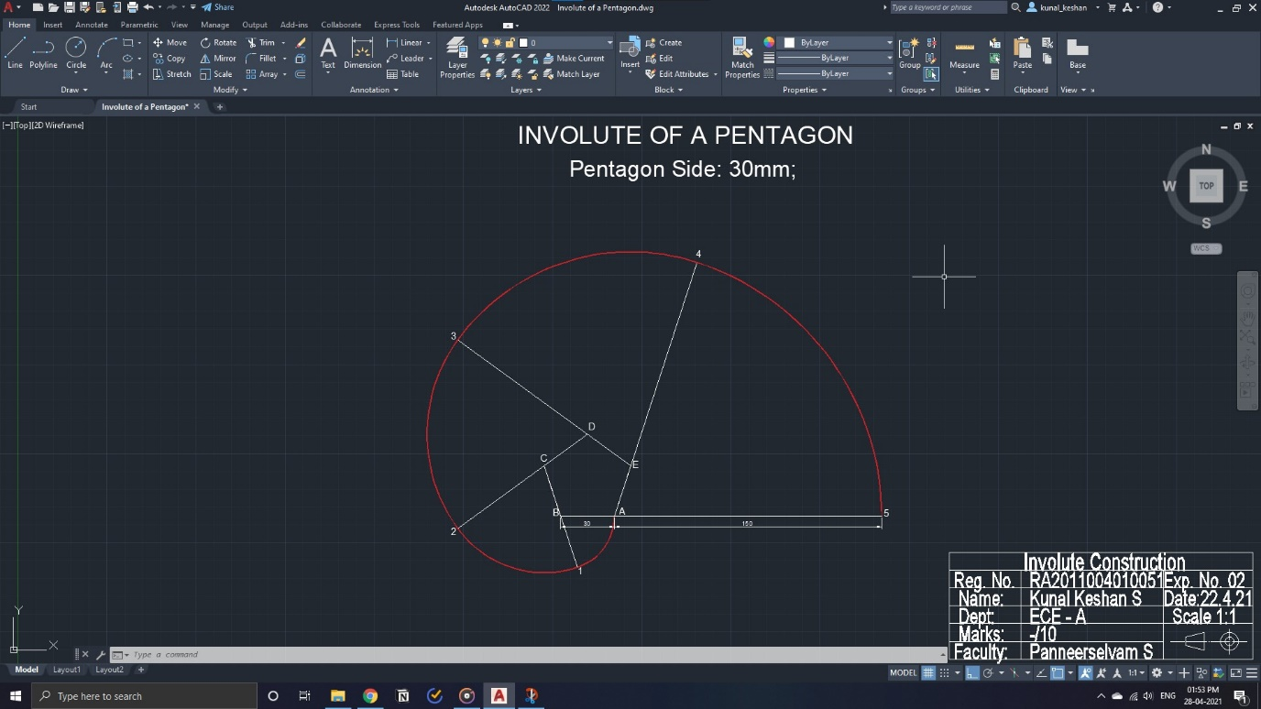

**Questions 6:** Draw an Archimedean spiral for one and half convolution. The greatest and the least radii being 70 mm and 10 mm respectively. Draw the tangent and normal method.

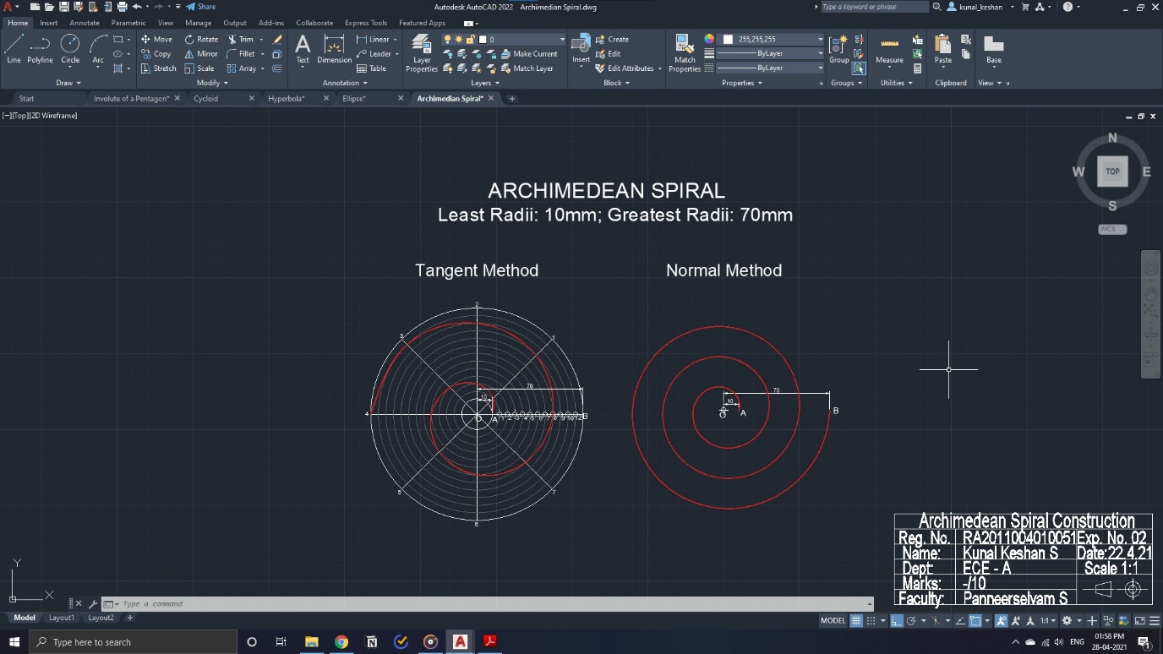

**Result:**

The specified special curves were drawn with the required dimensions.